**Lab 3: Cloudera Installation (VirtualBox)**

In this lab you are going to download and setup on your computers Oracle VirtualBox version 6.1.18 and subsequently create a Cloudera VM on VirtualBox.

* Part 1: Download and Setup Oracle VirtualBox
* Part 2: Create Cloudera VM on VirtualBox

**Part 1 - Download and Setup Oracle VirtualBox**

*Now please follow the steps given below:*

Go to <https://www.virtualbox.org/wiki/Downloads>

If you are using a Windows machine with **Microsoft Windows XP, 7, 8 or 10,** then your host machine is Windows. Download the first platform option for Windows hosts as shown in the following screenshot. (Note: If you are a Mac user, you need to download a VirtualBox-6.1.18 for OS X hosts (indicated in a red arrow below). Please also watch a YouTube video posted above.).

Now click Windows hosts (indicated in a green arrow below). You will see this link below the "VirtualBox 6.1.18 platform packages" heading. The VirtualBox EXE file will begin downloading onto your computer.

Now open the VirtualBox exe file. Go to the location to which the exe file downloaded and double-click the file. Doing so will open the VirtualBox installation window.

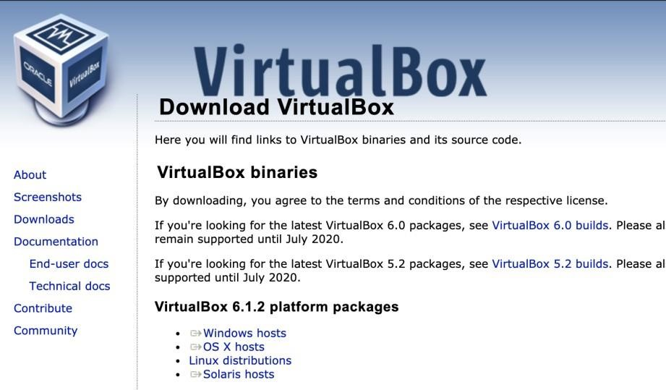

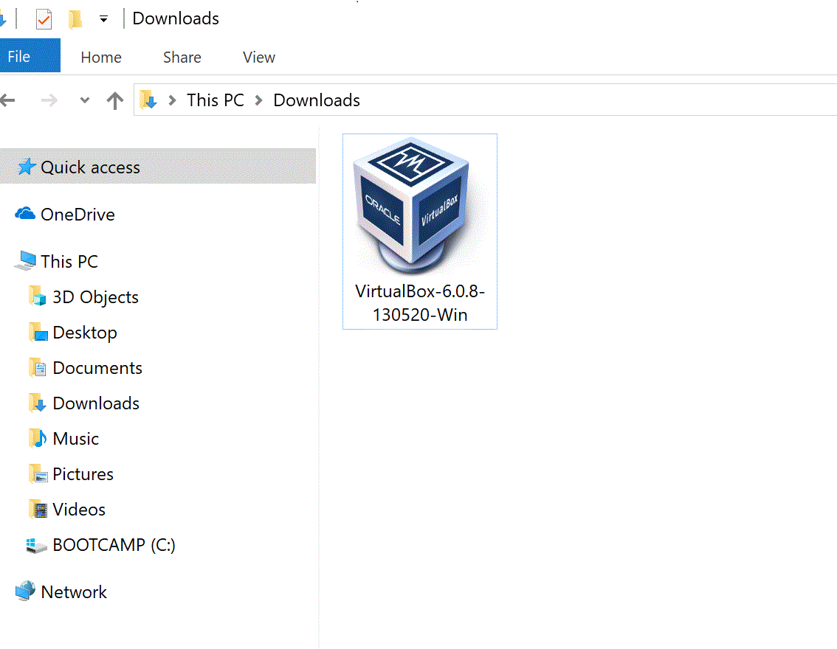

1. The Setup Wizard will open. Click “**Next >”**

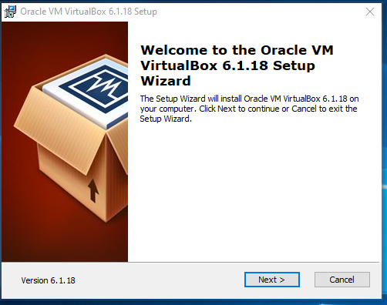

1. Click “**Next >”** again at the Custom Setup screen.

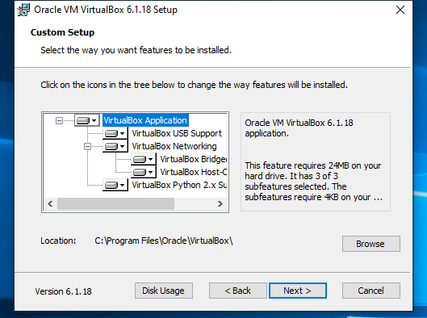

1. Click “**Next >”** again at the second “Custom Setup” screen.

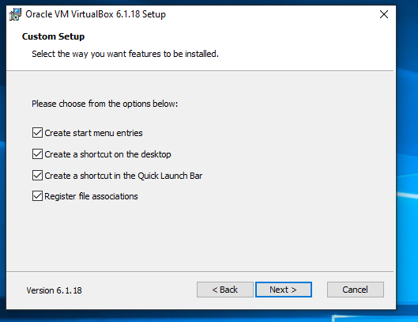

1. Click “**Yes”** at the **“Warning:”** screen.

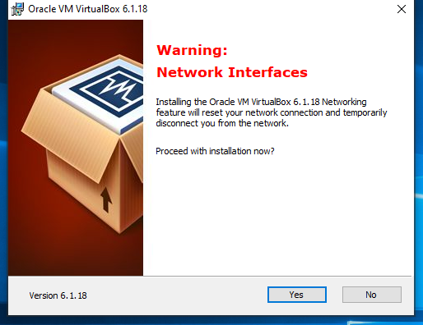

1. Click “**Install”** at the **“Ready to Install”** screen.

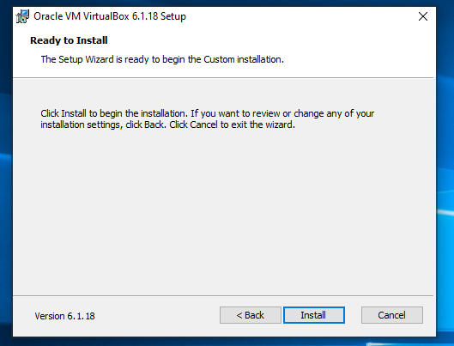

1. If the progress bar completes without reporting that the Setup Wizard has finished the installation, and if you see that the VirtualBox icon has appeared on your desktop, and that VirtualBox has been installed as a new program, then just close the Setup window and click on the VirtualBox icon to start the VirtualBox application.

You will see the following startup screen.



1. Create a **“New”** virtual machine. Give it a name and select Linux as the type and Ubuntu 64 bit. (or 64 bit if the option appears and if you have a 64 bit processor.) Click **“Next >”**

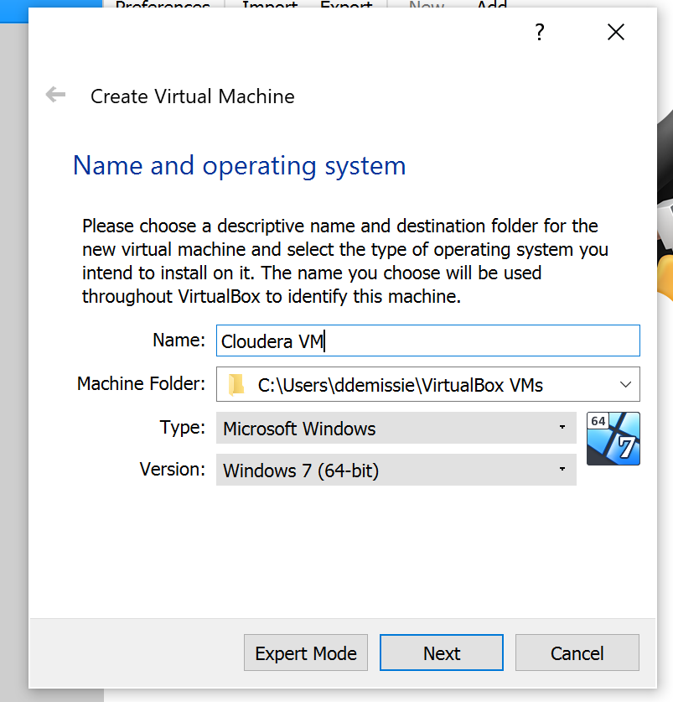

1. The more RAM you allocate for the machine, the faster it will run. This means that if you have 4 GB or more of RAM, you could easily allocate 3 GB here. You can find your system specifications at Administrative Tools or System Properties in the Control Panel. Allocate RAM and click **“Next >”**

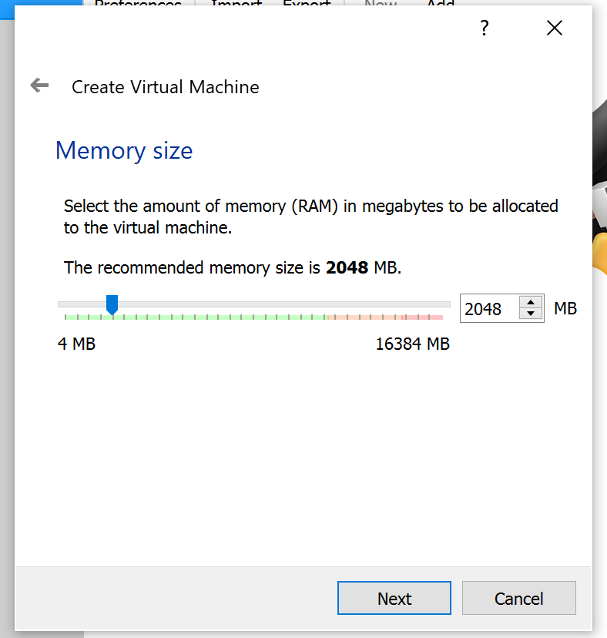

1. Keep **“Create a virtual hard drive now”** selected and click **“Create.”**

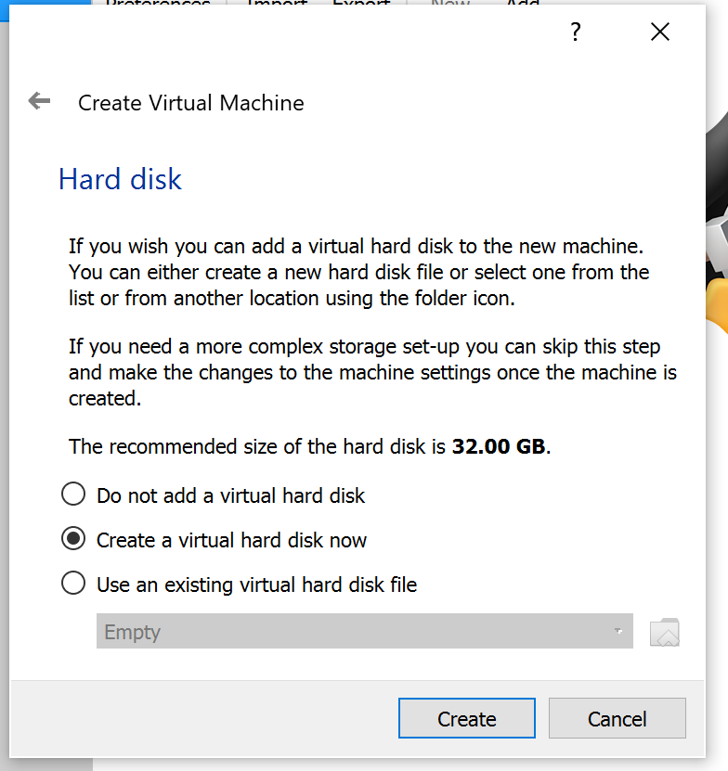

1. Keep VDI selected and click **“Next”.**

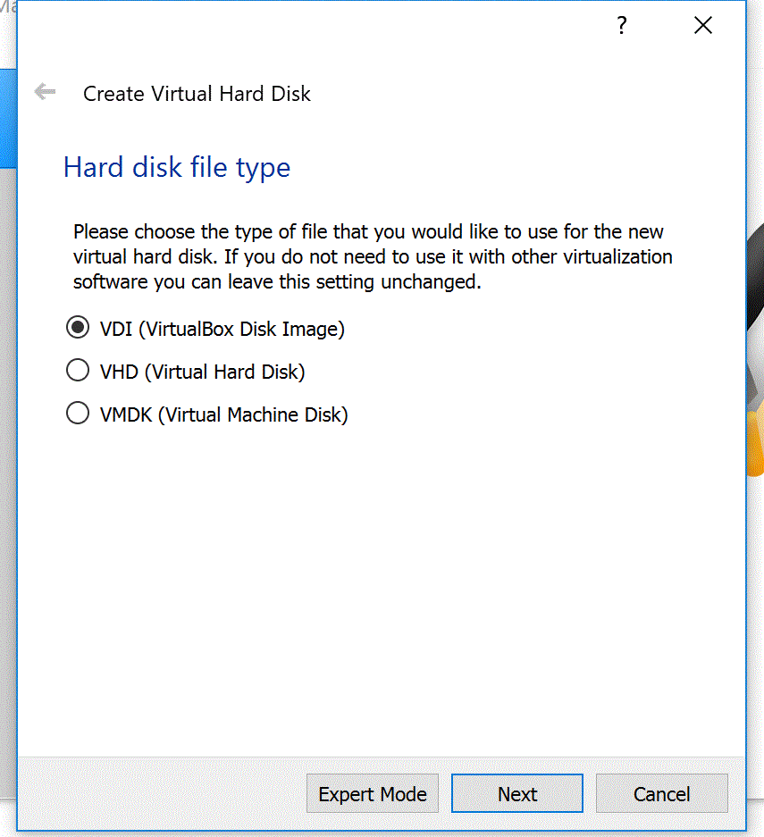

1. Keep **“Dynamically allocated”** selected and click **“Next >”**

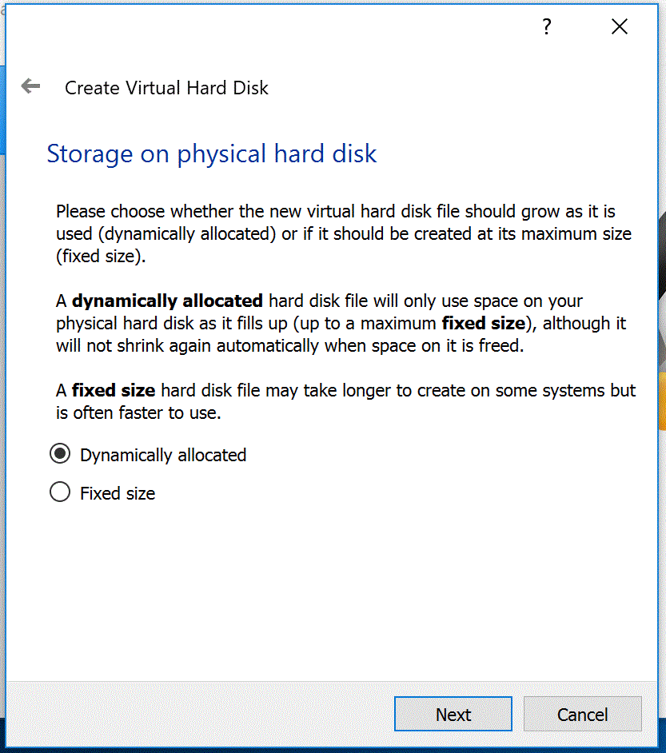

1. Allocate 10 GB to 32 for the virtual hard drive or more if you have a ton of free unused space on your hard drive and click on **“Create”.** Now that you have set up the virtual machine, you have to **“Start”** it and load the Cloudera VM.

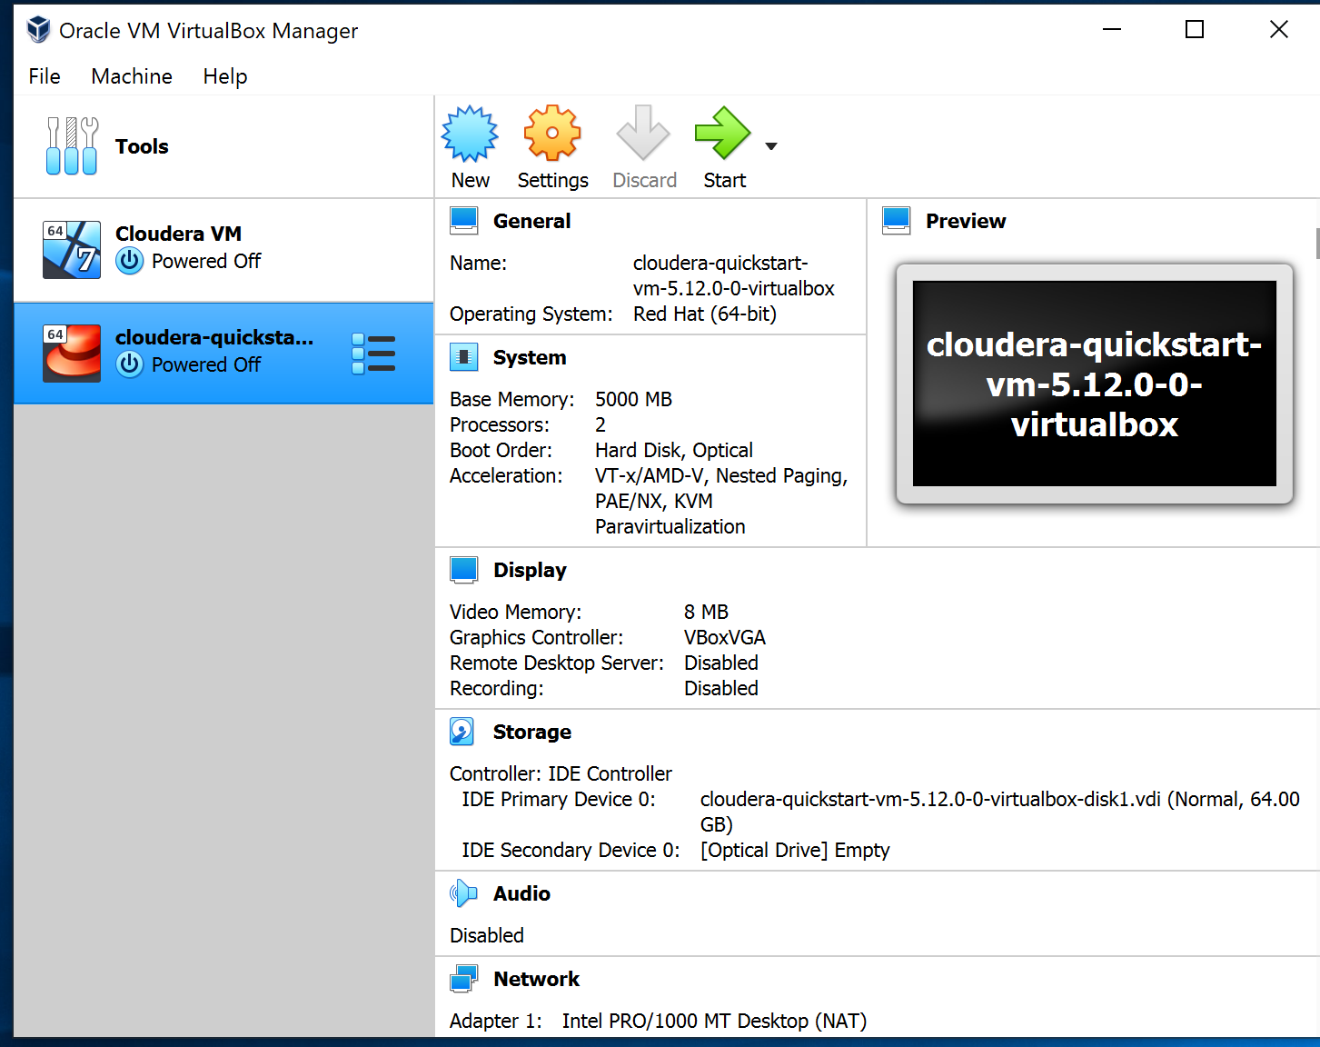

# Part 2: Download Cloudera QuickStart VM

Go to <https://downloads.cloudera.com/demo_vm/virtualbox/cloudera-quickstart-vm-5.12.0-0-virtualbox.zip> . Download and extract the zip file.

# Part 3: Create a new virtual machine and setup Cloudera

Open **VirtualBox**, go to **File** and select **Import Appliance**.

Browse your folders, find the extracted file, and select the **.ovf** file to import.

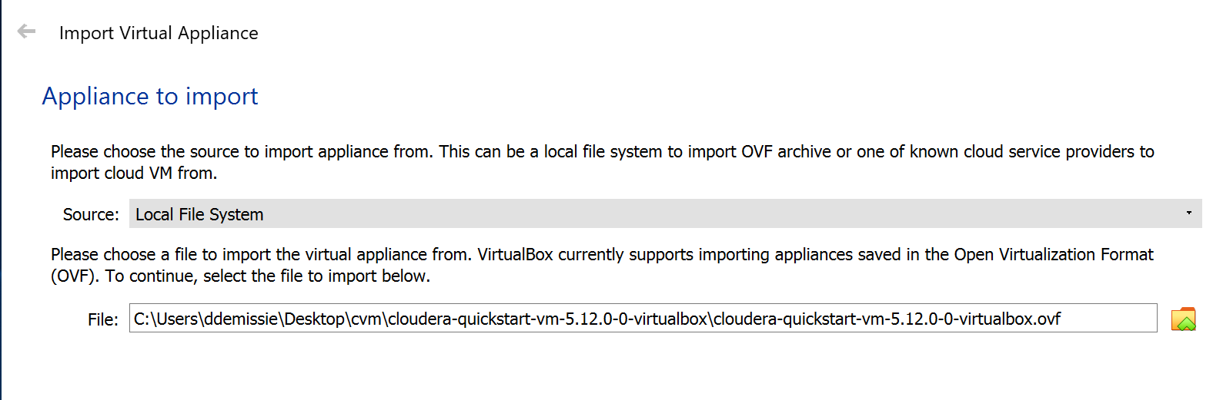

Click **Continue** and then **Import**. Keep the **default** settings for now.

Then, it will take a few minutes to set up the new VM. After the process is completed, right-click on the machine you just created and go to **settings**.

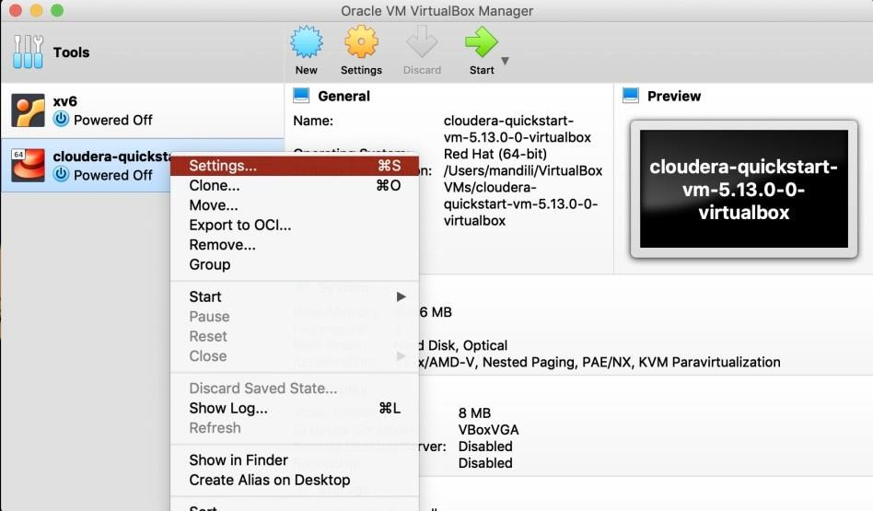

Go to **System**. 4096 MB is the minimum amount of RAM required. If you have more amount of RAM, you can assign more than 4096 MB. The more, the faster. Recommend 5000 MB. *However, be careful not to assign all the RAM to the VM.*

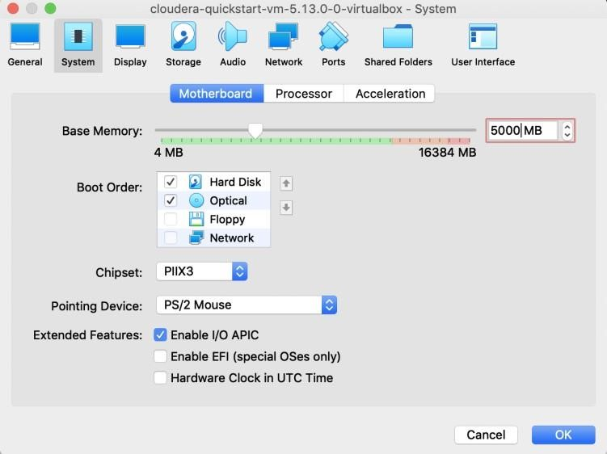

Under the **System** tab, go to **Processor**. And assign the number of cores that you want your VM to run on.

*Do not Assign a greater number of cores than you physically have on your machine.*

*If it is quad core, assign 4 cores maximum.*  *If it is dual core, assign 2 cores maximum.* Here, **assign 2 cores** to the VM.

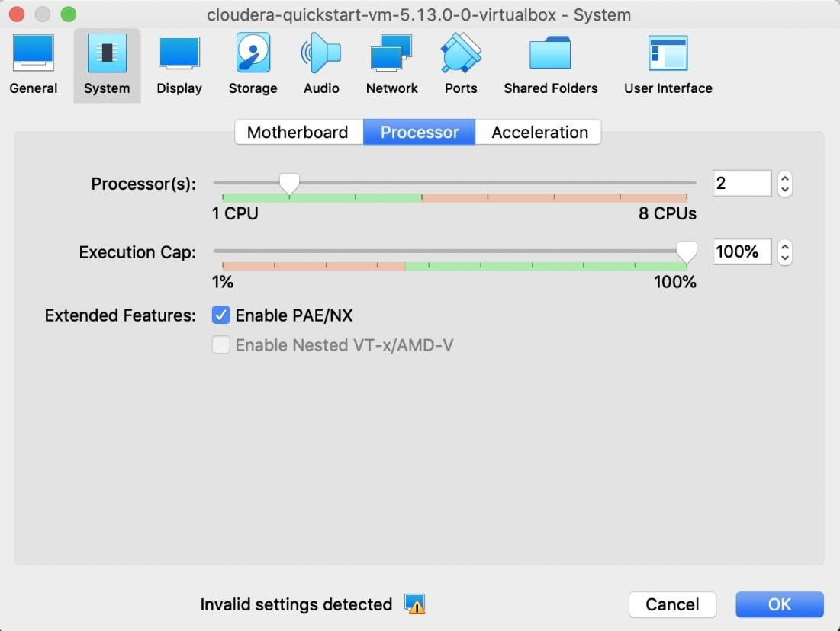

Go to **Network**, and you can change the settings here. The default setting here is fine.

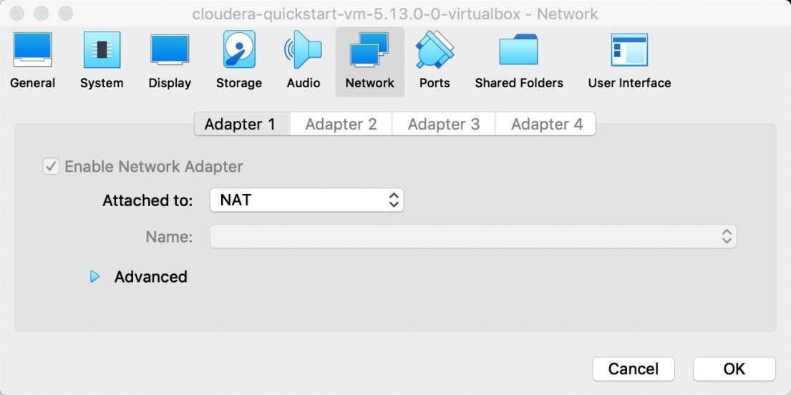

Click on **OK** and click the **Start** button to start the VM. It will take a few minutes for your VM to initialize.

**Note**: The terminal and web browser are located at the top left corner.

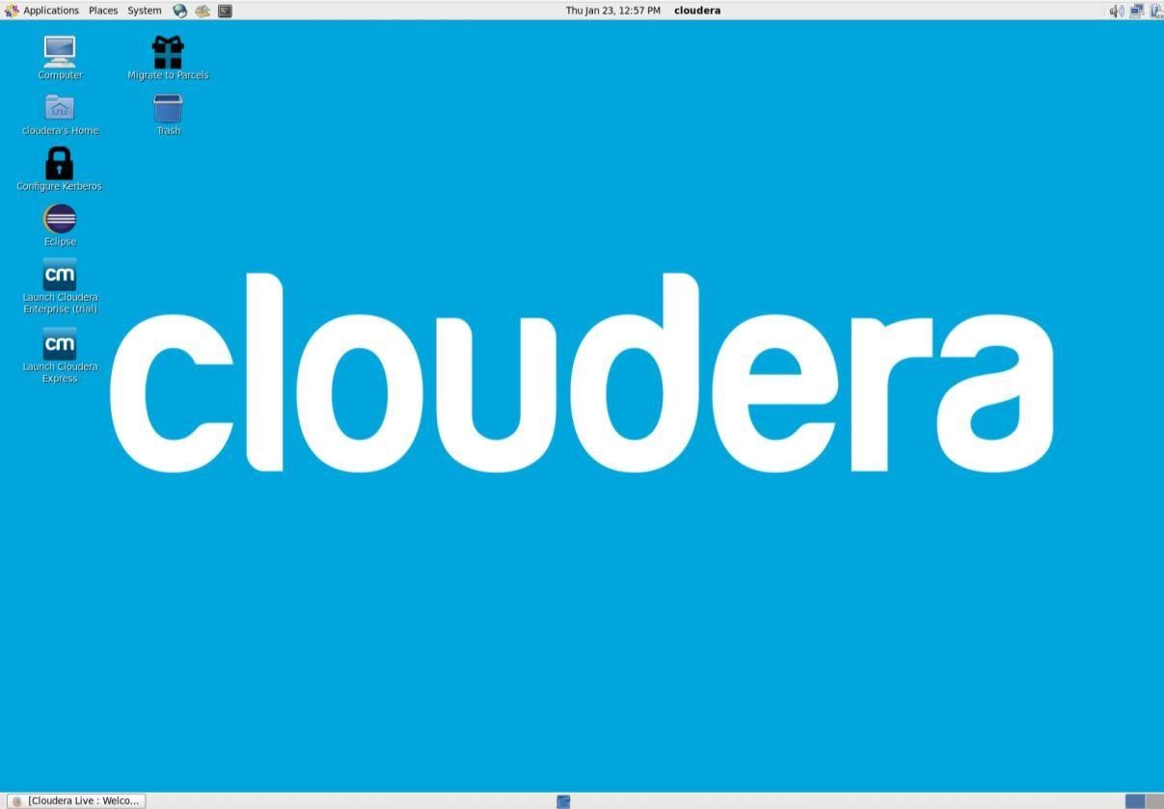

Terminal



Web Browser



# Part 4: Check out the Cloudera Manager

To make sure the Cloudera Manager is running on your VM, open the terminal and run **sudo**

**/home/cloudera/cloudera-manager --force –-express** command to reboot the

Cloudera Manager server. It will take a few seconds for the agent to restart.

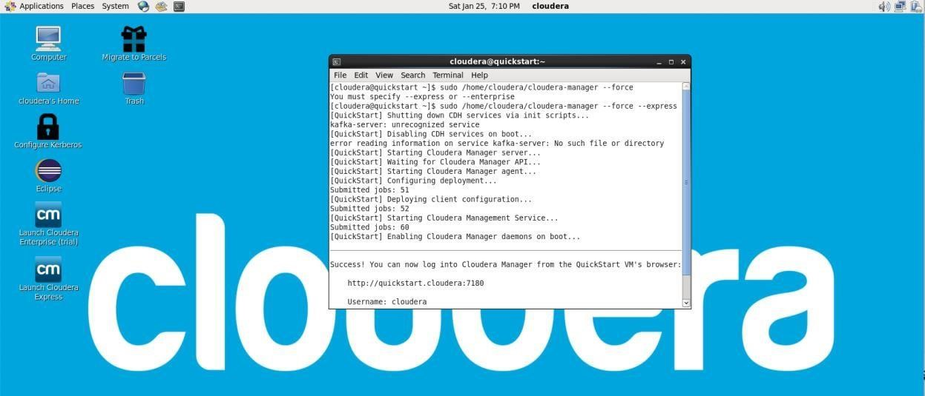

After the terminal finishing executing, open the **browser**, click, and go to the **Cloudera Manager**.

When you are at the login page, type in

**cloudera**

for both the username and the password.

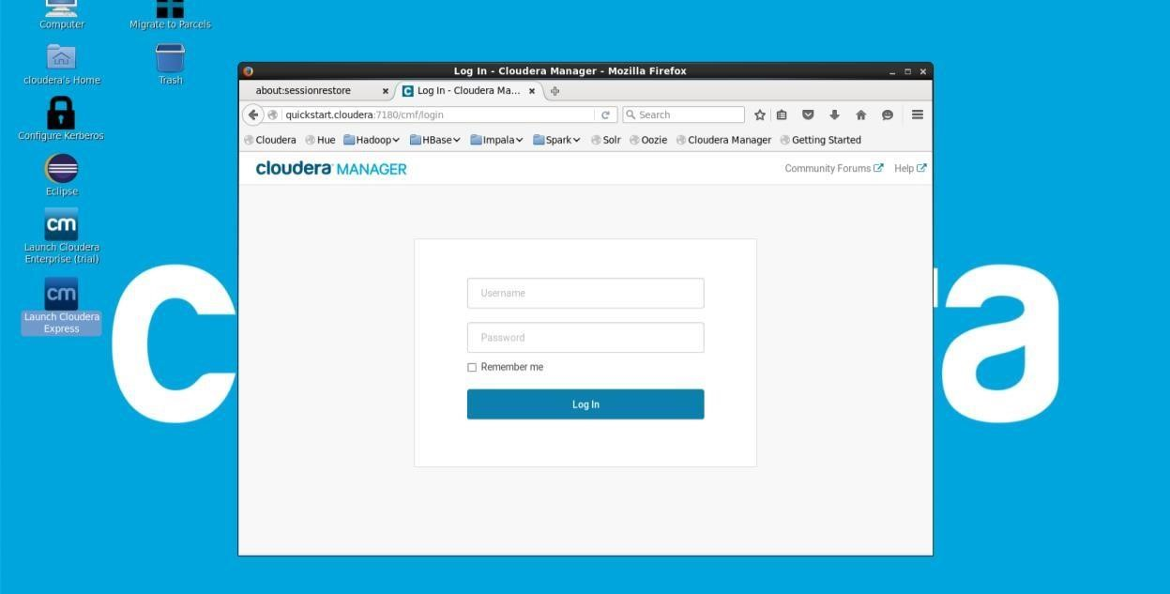

Now, you have logged on to the Cloudera Manager.

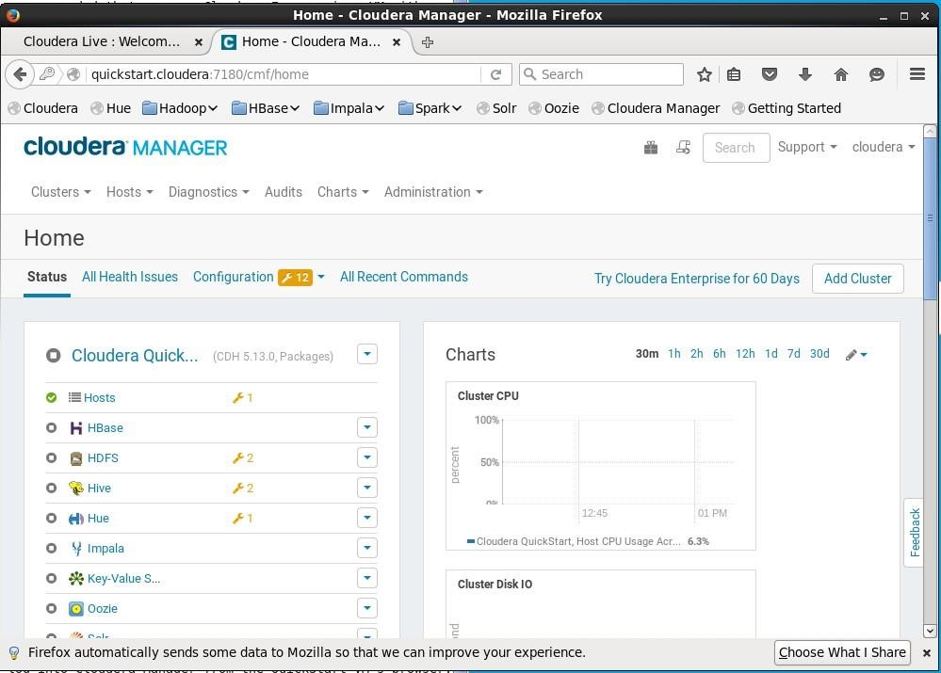

# Part 5: Close the VM

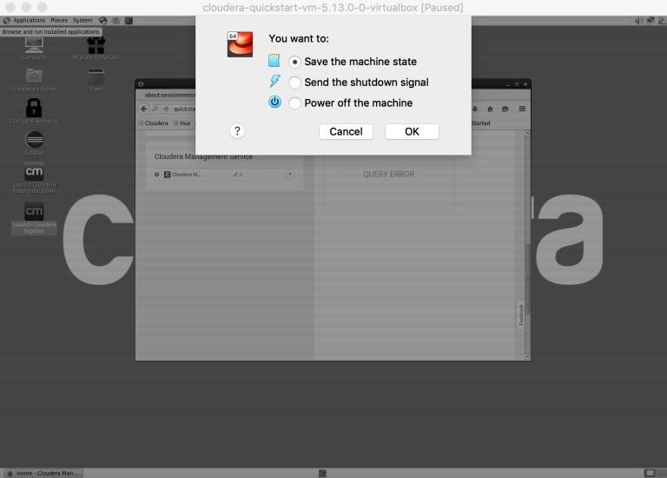

Remember to **save the machine state** after you have done working on it. It will save the machine state exactly the same at the time you exit, so when you start the machine next time, you can continue working on what was left.

For more detailed set-up tutorial, check this video:

<https://www.youtube.com/watch?v=HP4g2BU7-xU&t=578s>

Connect to Hive:

to check status sudo service hadoop-hdfs-

namenode status

to start

sudo service hadoop-hdfs-namenode start